Use-Case Realization Report
AddRole

Issue <1.0>
Revision History
Date | Issue | Description | Author
<dd/mmm/yy> | <x.x> | <details> | <name>

Table of Contents
1. Brief Description 4
2. Flow of Events 4
3. Interaction Diagrams 4
3.1 Collaboration Diagram for AddRole 4
3.2 Sequence Diagram for AddRole 5
4. Participating Objects 5
5. Class Diagrams 6
5.1 Class Diagram for AddRole 6
6. Derived Requirements 6

Use-Case Realization Report
AddRole

Brief Description

Flow of Events
[enter the flow of events here; you can use subsections to structure the text]

Interaction Diagrams

Collaboration Diagram for AddRole
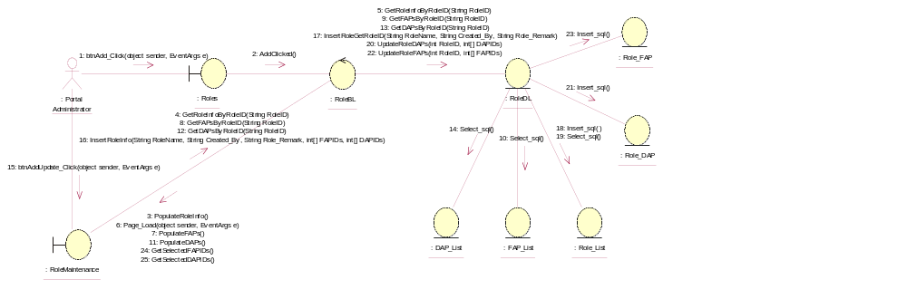

Sequence Diagram for AddRole
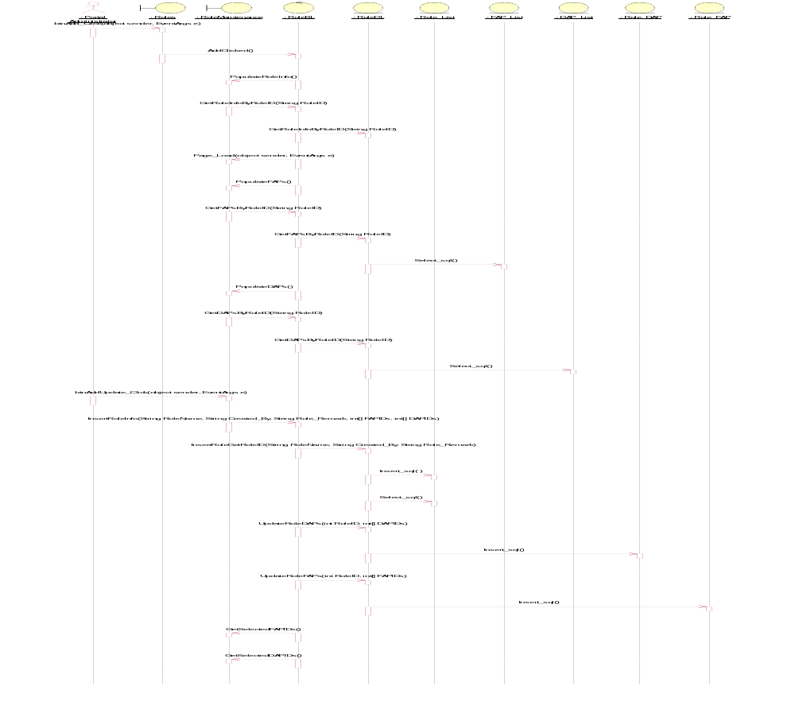

Participating Objects
: DAP_List

: FAP_List

: Portal Administrator

: Role_DAP

: Role_FAP

: Role_List

: RoleBL

: RoleDL

: RoleMaintenance

: Roles

Class Diagrams

Class Diagram for AddRole
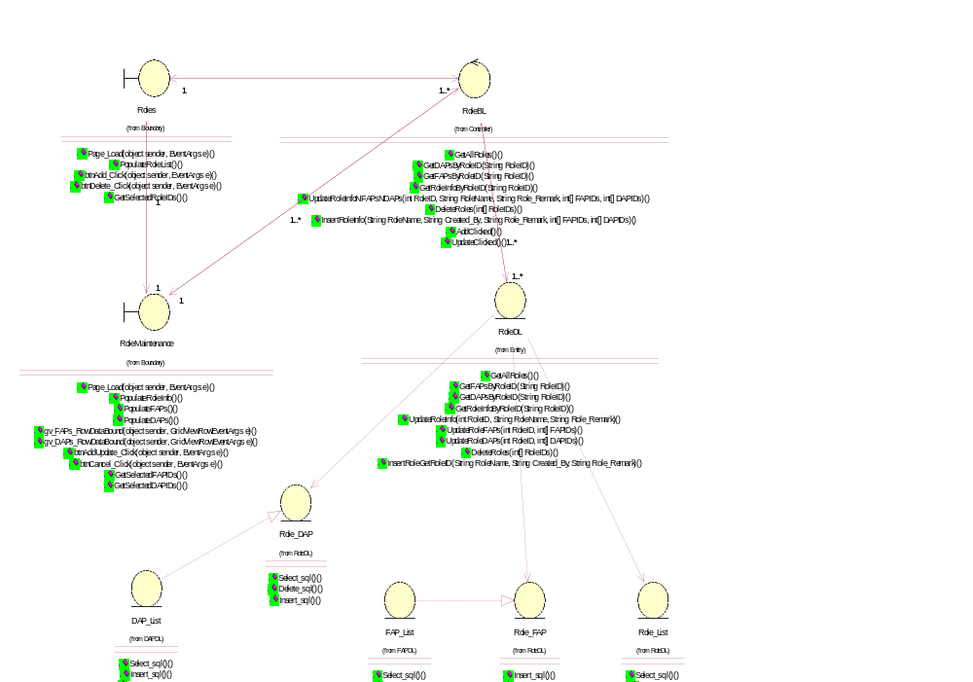

Derived Requirements
[enter the derived requirements here]

